Personal note for the Transport Secretary, Rt Hon Chris Grayling MP
John Healey MP and Ed Miliband MP

HS2: Comparing the costs and benefits of proposed South Yorkshire routes
This note summarises our main concerns about the new proposed HS2 route through South Yorkshire. It compares the proposed new ‘Eastern’ route with the previously published route via Meadowhall with an HS2 station, as any consultation or consideration of a change in route must do.
We have compiled the information working with local community action groups and drawing on HS2 documents and other official sources.

Reduced connectivity for South Yorkshire
- The spur line to Sheffield will not be High Speed.
- Journey time to from London to Sheffield increases from 68 minutes to 83 minutes (including Chesterfield stop).
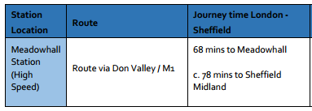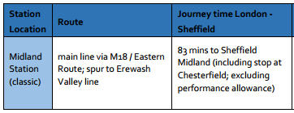
- Fewer HS2 trains stopping in South Yorkshire - from 5 trains to just 2 trains an hour.
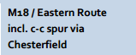
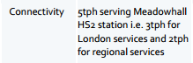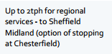

- No high-speed connection from Sheffield to Leeds.
- (Extracts taken from: HS2 Phase Two Sheffield and South Yorkshire Options Report, July 2016)
- No HS1 trains from Birmingham to Sheffield (HS2 has disclosed that their plan is for any train to Birmingham, to turn round and go back to London not to go on to Sheffield), and no HS2 Birmingham to Leeds services via Sheffield.

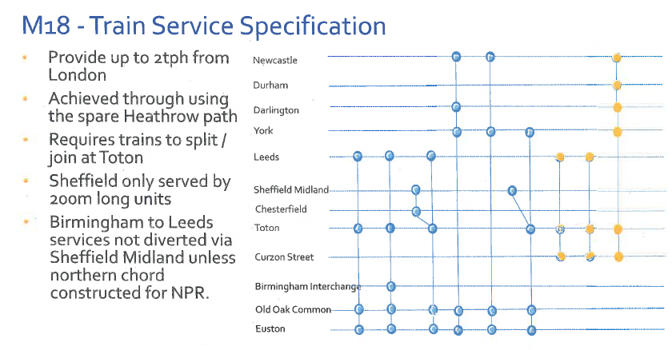
(Source: HS2 Ltd Economic Case presentation, Service Patterns, 2013)

Reduced economic benefits
- Loss of connectivity significantly reduces the economic benefits to the South Yorkshire area.
HS2 Chairman Sir David Higgins has previously said: “The third alternative we examined was a route which included a spur to Sheffield. This option considered a direct route via a spur terminating at Sheffield Midland station. While this provided limited benefits for the city centre market, it did not provide the connections and journey times necessary to serve the wider Sheffield city region effectively, particularly Rotherham and Barnsley. Furthermore, as Sheffield local leaders have also noted, introducing a terminating spur also removes the onward connections north to West Yorkshire and the North East provided by the current Y route.
“I do not believe these alternatives could deliver the same improvements in journey time and capacity as Phase Two, nor would they deliver an equitable approach across the North or meet the vision of a truly high speed network for the country.”
(Source: Rebalancing Britain: From HS2 towards a national transport strategy, 2014)
- Economic impact analysis, not yet published, compares the two route options and examines the relationship between train frequency, location, jobs and GVA. It demonstrates a much-reduced GVA per annum gain from the new route compared to the Meadowhall route.
- HS2 in building its economic case puts connectivity at the centre of its modelling, citing the relationship between connectivity and productivity. Diminished connectivity for Rotherham, Barnsley and Doncaster with the new proposed route, therefore, diminishes the potential economic gains.
- In light of the changes in connectivity and frequency, a detailed comparative assessment is now needed of the economic cost-benefits of the two possible HS2 routes through South Yorkshire. No decision should be made without this.

Increased disruption and demolition
- HS2 used out-of-date maps for the new route plans and for predicting the number of demolitions; these have therefore been underestimated.
- HS2 predicted 60 demolitions on the Meadowhall route and asserted that the latest plans would see an ‘overall reduction in demolitions expected, although route would impact a new development site between Conisbrough and Mexborough.’ (Sources: HS2: Sheffield Meadowhall Station, July 2013 and HS2 Phase Two Sheffield and South Yorkshire Options Report, July 2016)
- HS2 has no official figure predicting how many home are at risk under the latest plans. Responding to FOI16-1554, which sought clarification on the number of homes along the route that were considered to be in the Safeguarding Zone, HS2 stated: ‘I confirm that we do not hold recorded information in relation to your request.’
- Using up-to-date maps, local groups suggests around 500 demolitions on the new route, compared to 100 on the Meadowhall route.

Reduced cost savings
- The National Audit Office cites savings for the new route at £768m, which is reflected in the HS2 report on the new proposed route: ‘The recent NAO report quotes £768m savings (excludes efficiencies and optimism bias) which includes both the southern connection and northern connection between Sheffield and Leeds.’
(Source: HS2 Phase Two Sheffield and South Yorkshire Options Report)
- However, the ‘northern connection’ is the cost of the junction of the current track with HS2, and does not include the cost of any line upgrade
(Source: meeting with Transport Secretary and HS2 directors, 24.10.16)
- The Public Accounts Committee recently conclude the cost estimates for HS2 were still “volatile” and questioned whether the planned savings on phase 2 “can be delivered without adversely affecting the expected benefits of the programme”.
(Source: Public Accounts Committee Progress with preparations for HS2, September 2016)
- According to HS2, their £1bn cost saving on the new route would be achieved through the following major savings:
Land & Property £395.19m
Bored Tunnels £195.19m
Viaducts £422.14m
Sheffield Meadowhall Station £336.73m

(Source: Figures provided by HS2 in response to FOI16-1571)

- There can be no genuine estimation of land and property cost savings unless current maps are used to include the additional cost of compulsory purchase, demolition and noise compensation.
- An essential South Yorkshire parkway station on the new route – the subject of a special study commissioned by the Transport Secretary – is likely to add at least £100m to the cost of this route and offset some of the savings from not building at Meadowhall.
- The cost of completing an upgraded link from Sheffield to Leeds is not included.

Conclusion
The case for changing the HS2 route through South Yorkshire to the new proposed ‘Eastern’ is much weaker than the original Meadowhall route, with greatly reduced connectivity and economic gains to the wider South Yorkshire area. Moreover the case for the new HS2 route is flawed, with smaller cost savings and more demolitions and disruption than the HS2 report claims.
The Government should stick to the planned Meadowhall route and drop plans for the new ‘Eastern’ route. If the Transport Secretary does give the go-ahead for consultation on the new proposed route, then this should be a consultation that compares views on and economic assessments of the two routes together.

October 2016

